<Letterhead>

<Date>
Dear <senior leader, director, governor or trustee>,
I am writing to you with the results of a budget benchmarking process that I have recently undertaken. I have compared our CPD budget with that of similar schools and other local schools.
I used the Teacher Development Trust’s benchmarking tool and found that a number of local and similar schools seems to be outspending us on professional development for their staff. This seems particularly relevant given national pressures on recruitment and retention as well as the ongoing pressure to keep raising standards.
[You may wish to insert some more details here]
Ofsted says that schools should be improving staff practice and teaching, learning and assessment through rigorous performance management and appropriate professional development. The Department for Education and Regional School Commissioners refer to the DfE Standards for Teachers’ Professional Development which state that “professional development must be prioritised by school leadership” and “school leaders [should] make evidence-informed development a major leadership priority”.
The evidence is strong for CPD as a school improvement strategy. The graph below (Figure 1) shows the improvement trajectory of teachers in two types of schools – the lower line shows that teachers stop making progress in schools with poor support for CPD while the upper line shows how teachers keep improving impact on pupil outcomes when they stay in schools with stronger leadership, culture and processes of professional development. Teachers spending 10 years in the schools represented by the top line were shown to be gaining around 40% more pupil progress each year than teachers in the schools represented by the lower line.
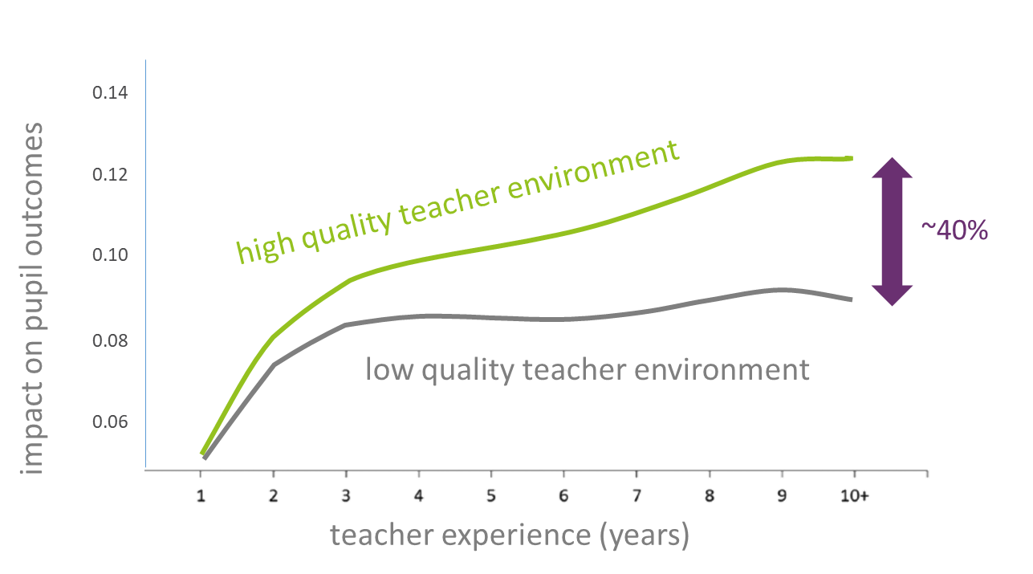
Figure 1 - Taken from Kraft and Papay, 2014

The teacher environment in this study included: the amount of high quality CPD that teachers felt was relevant to their practice, the amount of time for teachers to collaborate to apply their learning, the culture of learning including the levels of mutual trust and openness, and the extent to which appraisal and performance management felt that it was developmental and supportive.
Another study, by LKMco and Pearson, looked at factors that supported recruitment and retention of talented teachers, and found that “Career progression […] and school-focused factors like culture and ethos are particularly important to school leaders.” It also found that “opportunities for career progression and professional development exerted a particularly strong influence over the younger teachers”.
Taking these factors together, it’s clear that professional development can be used as a highly targeted approach to improve pupil outcomes, increase morale and reduce our average spend on recruitment. I would like to find a time in the near future to explore how we might do two things:
- Increase our school’s budget for professional development
- See how we can work on the key aspects of CPD and culture mentioned in the documents and studies that I’ve mentioned above.
Yours sincerely,

Name
Role

References:
Department for Education, 2015. Standards for Teachers Professional Development. https://tdtrust.org/research/dfe-cpd-standard
Kraft, M.A. & Papay, J.P., 2014. Do supportive professional environments promote teacher development? Explaining heterogeneity in returns to teaching experience. Educational Evaluation and Policy Analysis. https://scholar.harvard.edu/files/mkraft/files/kraft_papay_-_prof_env_teacher_development_eepa_full.pdf
Menzies, L. et al (2015). Why Teach? LKMco and Pearson. http://whyteach.lkmco.org/wp-content/uploads/2015/10/Embargoed-until-Friday-23-October-2015-Why-Teach.pdf
Ofsted, 2018. School inspection handbook. https://www.gov.uk/government/publications/school-inspection-handbook-from-september-2015

